Concentric Rings

Definition
# Source: AI Source: Provided by: [Data Path: Persons Table -> ID Column: 1, Name_En Column: Motasem Essam] -> From: [ChatGPT] on [7/25/2026]
Concentric Rings are two or more ring-shaped regions arranged around the same center, with each ring surrounding the next.
The rings have a common central point $O$, while their inner and outer boundaries occur at different distances from $O$.
For circular rings, the boundaries are concentric circles.
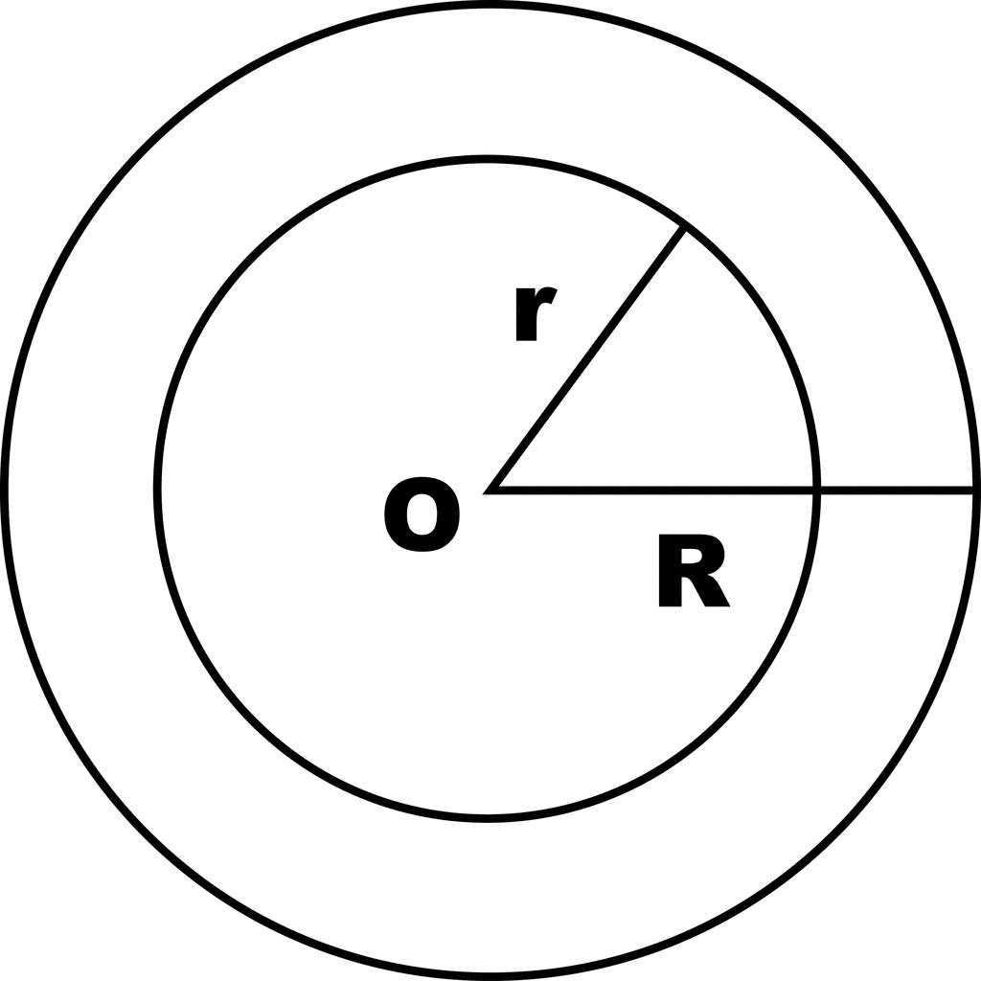
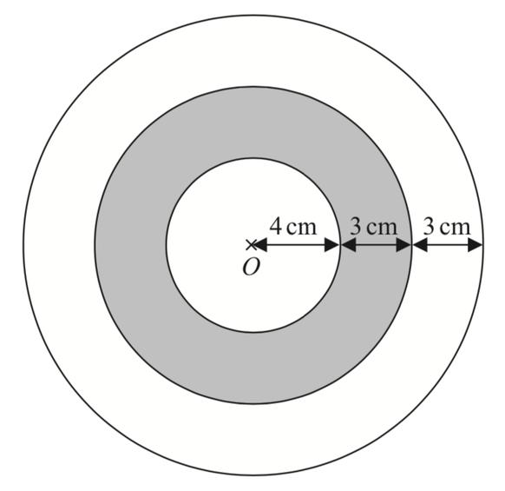
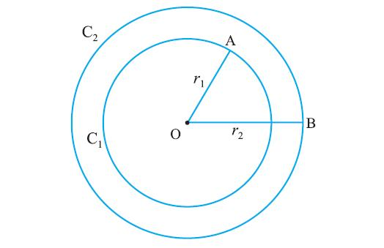
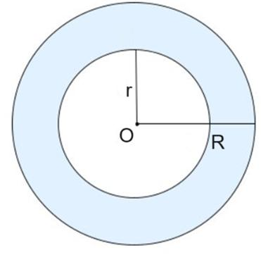
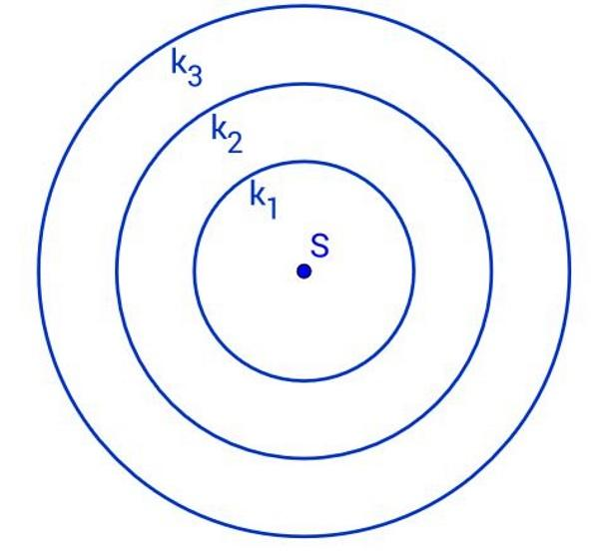

Fundamental Concept
# Source: AI Source: Provided by: [Data Path: Persons Table -> ID Column: 1, Name_En Column: Motasem Essam] -> From: [ChatGPT] on [7/25/2026]
The fundamental structure is:
Common center + nested ring regions + different radial boundaries
For two concentric circular rings:
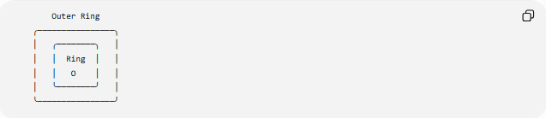
Outer Ring
╭────────────────╮
│ ╭────────╮ │
│ │ Ring │ │
│ │ O │ │
│ ╰────────╯ │
╰────────────────╯
The center $O$is common to all boundaries.
A circular ring is bounded by:
- an outer circle with radius $R$
- an inner circle with radius $r$
where:
$$R>r$$

Main Characteristics
# Source: AI Source: Provided by: [Data Path: Persons Table -> ID Column: 1, Name_En Column: Motasem Essam] -> From: [ChatGPT] on [7/25/2026]
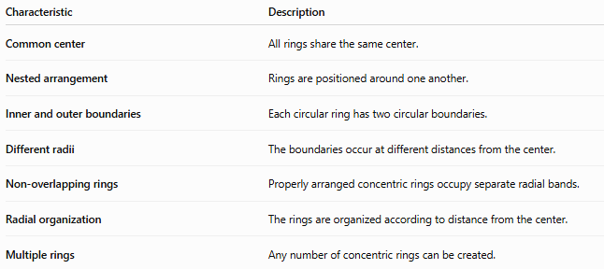
Characteristic | Description
Common center | All rings share the same center.
Nested arrangement | Rings are positioned around one another.
Inner and outer boundaries | Each circular ring has two circular boundaries.
Different radii | The boundaries occur at different distances from the center.
Non-overlapping rings | Properly arranged concentric rings occupy separate radial bands.
Radial organization | The rings are organized according to distance from the center.
Multiple rings | Any number of concentric rings can be created.

Basic Structure of a Circular Ring
# Source: AI Source: Provided by: [Data Path: Persons Table -> ID Column: 1, Name_En Column: Motasem Essam] -> From: [ChatGPT] on [7/25/2026]
A single circular ring, also called an annulus, is bounded by two concentric circles.
Let:
- $O$= common center
- $r$= inner radius
- $R$= outer radius
Then:
$$R>r$$
The ring thickness is:
$$\boxed{t=R-r}$$
Its area is:
$$\boxed{A=π\left(R^{2}-r^{2}\right)}$$
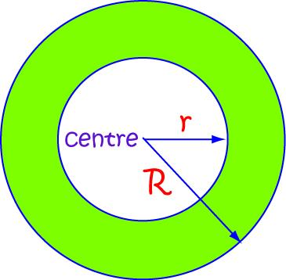
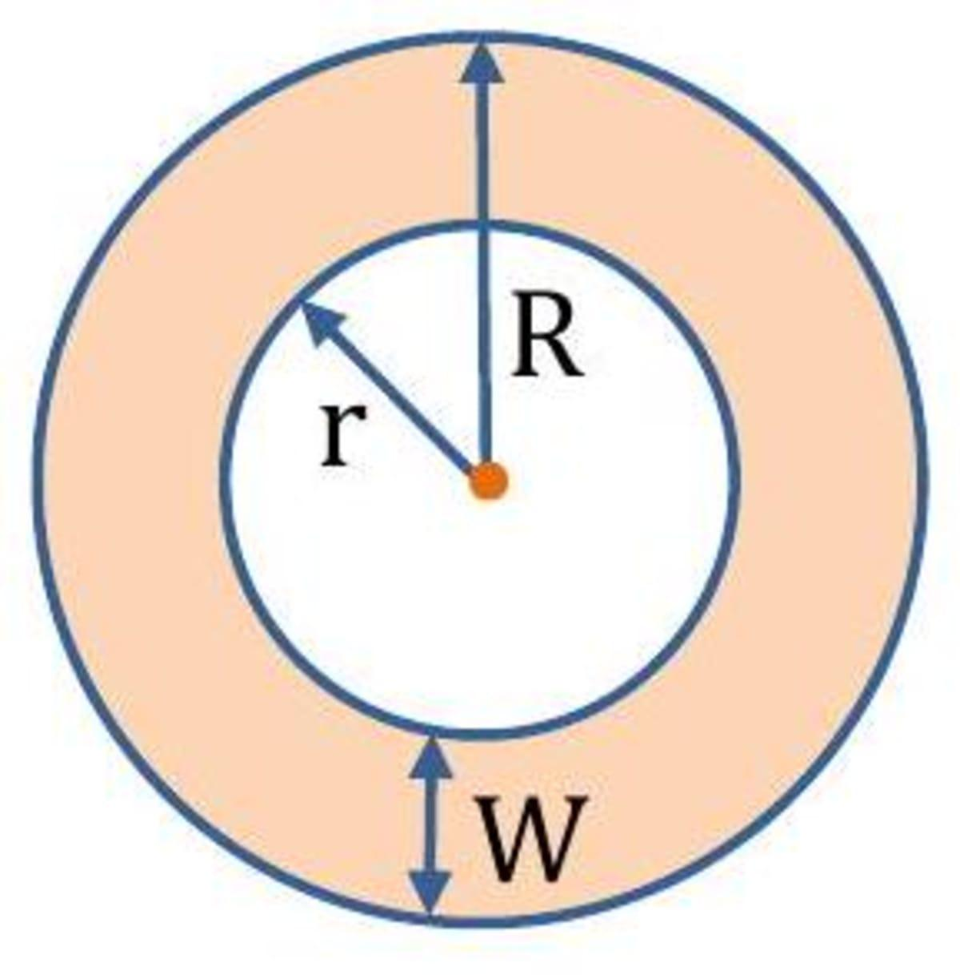
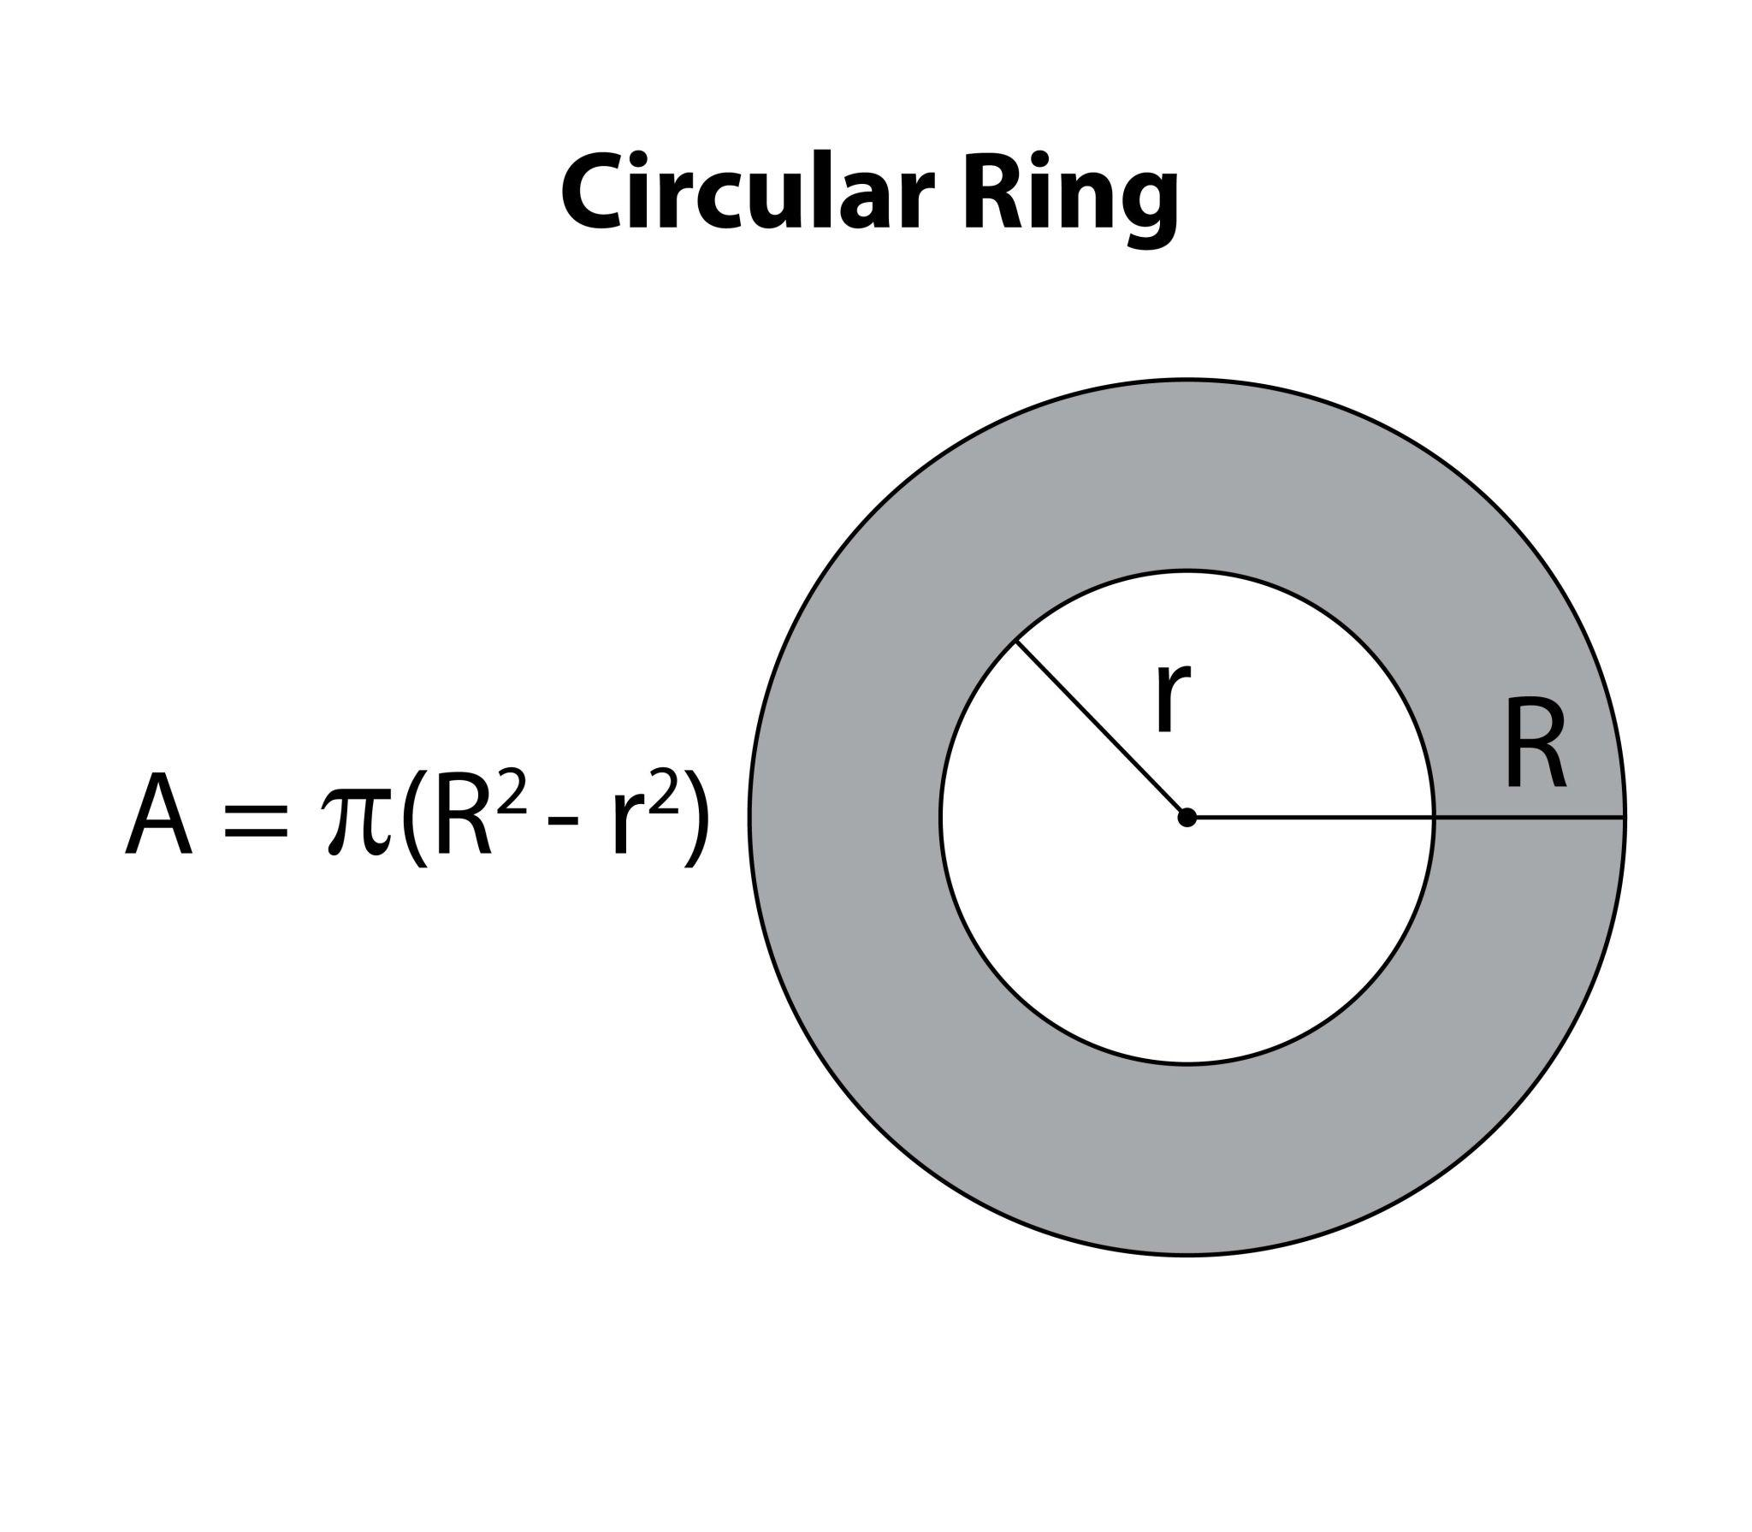
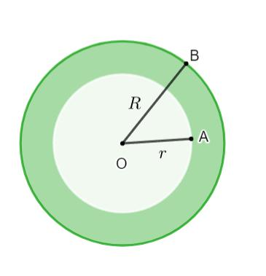

Types of Concentric Rings
# Source: AI Source: Provided by: [Data Path: Persons Table -> ID Column: 1, Name_En Column: Motasem Essam] -> From: [ChatGPT] on [7/25/2026]
A useful classification is:
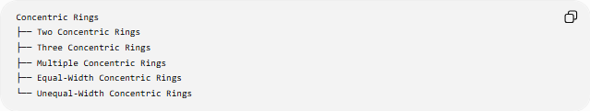
Concentric Rings
├── Two Concentric Rings
├── Three Concentric Rings
├── Multiple Concentric Rings
├── Equal-Width Concentric Rings
└── Unequal-Width Concentric Rings

Two Concentric Rings
# Source: AI Source: Provided by: [Data Path: Persons Table -> ID Column: 1, Name_En Column: Motasem Essam] -> From: [ChatGPT] on [7/25/2026]
Two concentric rings consist of two ring-shaped regions sharing the same center.
For example:
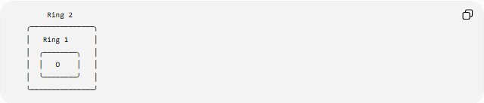
Ring 2
╭───────────────╮
│ Ring 1 │
│ ╭────────╮ │
│ │ O │ │
│ ╰────────╯ │
╰───────────────╯
The rings occupy two different radial intervals.
If the first ring occupies:
$$r_{1}≤r≤R_{1}$$
and the second occupies:
$$r_{2}≤r≤R_{2}$$
then, for non-overlapping nested rings:
$$R_{1}≤r_{2}$$

Three Concentric Rings
# Source: AI Source: Provided by: [Data Path: Persons Table -> ID Column: 1, Name_En Column: Motasem Essam] -> From: [ChatGPT] on [7/25/2026]
Three rings can be arranged around the same center:
$$O_{1}=O_{2}=O_{3}=O$$
For example:
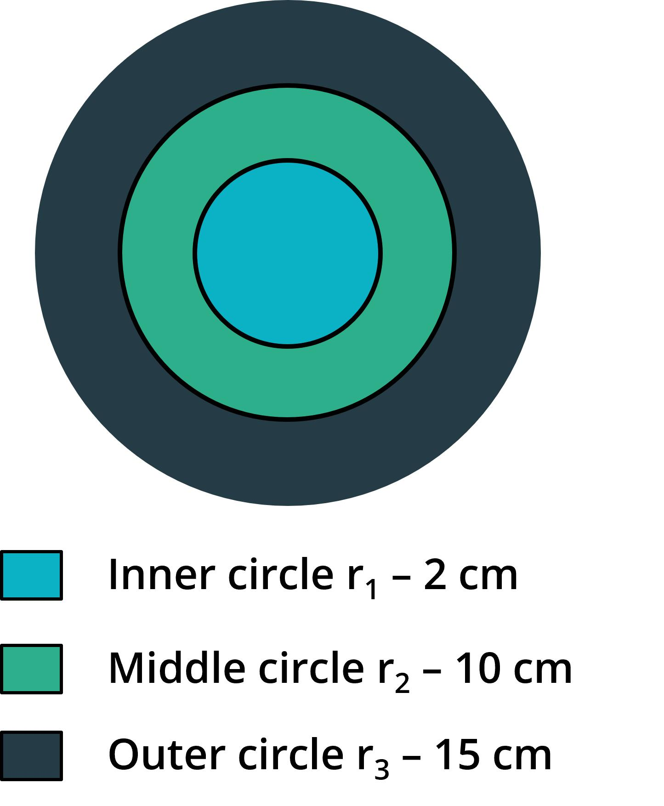
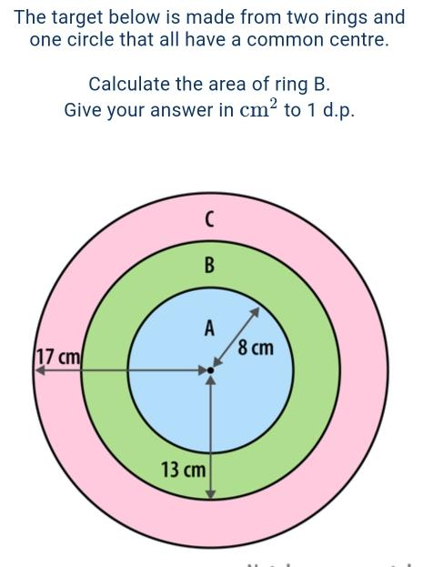
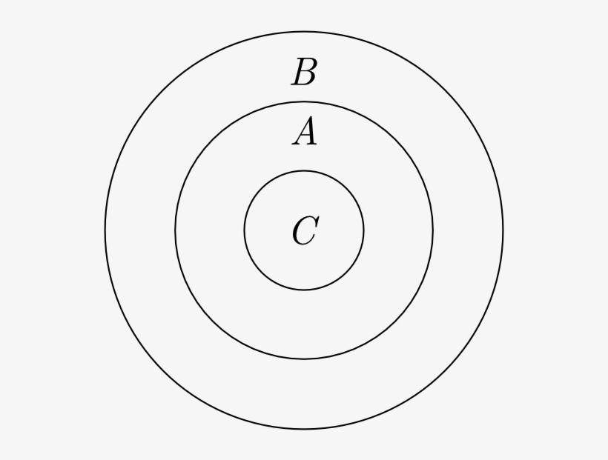
Each ring occupies a separate radial interval.
For example:
$$1≤r≤2 \\ 3≤r≤4 \\ 5≤r≤6$$
The gaps between them are separate regions.

Multiple Concentric Rings
# Source: AI Source: Provided by: [Data Path: Persons Table -> ID Column: 1, Name_En Column: Motasem Essam] -> From: [ChatGPT] on [7/25/2026]
Any number of rings can share the same center.
For $n$concentric rings:
$$O_{1}=O_{2}=⋯=O_{n}=O$$
Each ring can be described by an inner and outer radius:
$$r_{i}≤ρ≤R_{i}$$
where $ρ$represents the distance from the common center.
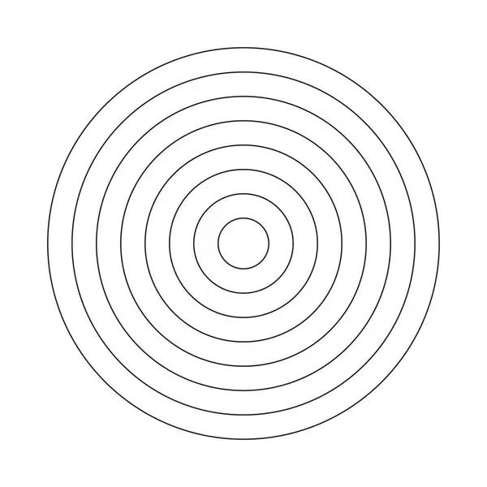


Equal-Width Concentric Rings
# Source: AI Source: Provided by: [Data Path: Persons Table -> ID Column: 1, Name_En Column: Motasem Essam] -> From: [ChatGPT] on [7/25/2026]
Equal-width concentric rings have the same radial thickness.
For each ring:
$$t_{i}=R_{i}-r_{i}$$
If all widths are equal:
$$t_{1}=t_{2}=⋯=t_{n}=t$$
For example:
$$t=2$$
could produce:
$$1≤ρ≤3 \\ 3≤ρ≤5 \\ 5≤ρ≤7$$
The boundaries are therefore evenly spaced in the radial direction.

Unequal-Width Concentric Rings
# Source: AI Source: Provided by: [Data Path: Persons Table -> ID Column: 1, Name_En Column: Motasem Essam] -> From: [ChatGPT] on [7/25/2026]
Unequal-width concentric rings have different radial thicknesses.
For example:
$$t_{1}=2 \\ t_{2}=3 \\ t_{3}=1$$
where:
$$t_{i}=R_{i}-r_{i}$$
The rings still share the same center even though their widths differ.
Therefore:
Equal width is not required for concentricity.

Mathematical Representation
# Source: AI Source: Provided by: [Data Path: Persons Table -> ID Column: 1, Name_En Column: Motasem Essam] -> From: [ChatGPT] on [7/25/2026]
For circular concentric rings, polar coordinates provide a simple representation.
A ring can be written as:
$$r≤ρ≤R$$
where:
- $r$= inner radius
- $R$= outer radius
- $ρ$= distance from the common center
For multiple rings:
$$r_{1}≤ρ≤R_{1} \\ r_{2}≤ρ≤R_{2} \\ ⋯ \\ r_{n}≤ρ≤R_{n}$$
All of them use the same center.

Area of a Concentric Ring
# Source: AI Source: Provided by: [Data Path: Persons Table -> ID Column: 1, Name_En Column: Motasem Essam] -> From: [ChatGPT] on [7/25/2026]
For a single circular ring:
$$\boxed{A=π\left(R^{2}-r^{2}\right)}$$
Using the difference of squares:
$$A=π\left(R-r\right)\left(R+r\right)$$
Since:
$$t=R-r$$
we can also write:
$$\boxed{A=πt\left(R+r\right)}$$

Area of Multiple Concentric Rings
# Source: AI Source: Provided by: [Data Path: Persons Table -> ID Column: 1, Name_En Column: Motasem Essam] -> From: [ChatGPT] on [7/25/2026]
If several non-overlapping concentric rings are present, the total area is the sum of their individual areas:
$$A_{\text{total}}=\sum_{i=1}^{n}{π}\left(R_{i}^{2}-r_{i}^{2}\right)$$
Therefore:
$$\boxed{A_{\text{total}}=π\sum_{i=1}^{n}{(}\left.R_{i}^{2}-r_{i}^{2}\right)}$$
provided the rings do not overlap.

Circumferences of the Boundaries
# Source: AI Source: Provided by: [Data Path: Persons Table -> ID Column: 1, Name_En Column: Motasem Essam] -> From: [ChatGPT] on [7/25/2026]
Each circular boundary has circumference:
$$C=2πr$$
Therefore, a ring has:
Inner circumference
$$C_{\text{inner}}=2πr$$
Outer circumference
$$C_{\text{outer}}=2πR$$
The difference is:
$$C_{\text{outer}}-C_{\text{inner}}=2π\left(R-r\right)$$
or:
$$\boxed{ΔC=2πt}$$

Concentric Rings vs. Concentric Circles
# Source: AI Source: Provided by: [Data Path: Persons Table -> ID Column: 1, Name_En Column: Motasem Essam] -> From: [ChatGPT] on [7/25/2026]
These terms describe related but different objects.
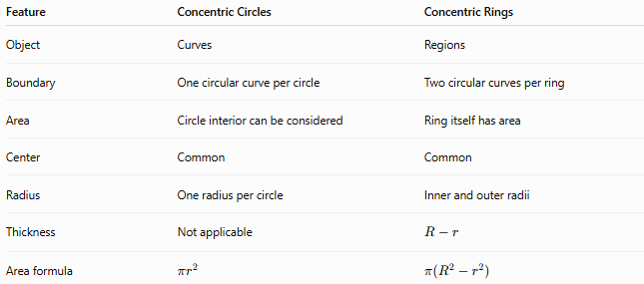
Feature | Concentric Circles | Concentric Rings
Object | Curves | Regions
Boundary | One circular curve per circle | Two circular curves per ring
Area | Circle interior can be considered | Ring itself has area
Center | Common | Common
Radius | One radius per circle | Inner and outer radii
Thickness | Not applicable | $$R-r$$
Area formula | $$πr^{2}$$ | $$π\left(R^{2}-r^{2}\right)$$
Important:
A concentric ring is a region between two concentric circles, not simply another circle.

Concentric Rings vs. Annuli
# Source: AI Source: Provided by: [Data Path: Persons Table -> ID Column: 1, Name_En Column: Motasem Essam] -> From: [ChatGPT] on [7/25/2026]
A circular ring is commonly called an annulus.
Therefore, a set of concentric circular rings can also be described as a set of concentric annular regions.
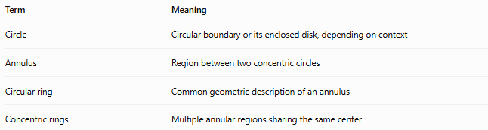
Term | Meaning
Circle | Circular boundary or its enclosed disk, depending on context
Annulus | Region between two concentric circles
Circular ring | Common geometric description of an annulus
Concentric rings | Multiple annular regions sharing the same center

Example
# Source: AI Source: Provided by: [Data Path: Persons Table -> ID Column: 1, Name_En Column: Motasem Essam] -> From: [ChatGPT] on [7/25/2026]
Suppose two concentric rings have:
First ring:
$$r_{1}=2, R_{1}=4$$
Second ring:
$$r_{2}=6, R_{2}=9$$
First ring area
$$A_{1}=π\left(4^{2}-2^{2}\right) \\ A_{1}=12π$$
Second ring area
$$A_{2}=π\left(9^{2}-6^{2}\right) \\ A_{2}=45π$$
Total area
$$A_{\text{total}}=12π+45π \\ \boxed{A_{\text{total}}=57π}$$
square units.

Concentric Rings in Different Geometric Forms
# Source: AI Source: Provided by: [Data Path: Persons Table -> ID Column: 1, Name_En Column: Motasem Essam] -> From: [ChatGPT] on [7/25/2026]
Although the term concentric ring most commonly refers to circular rings, similar ring-like regions can be constructed from other centrally organized boundaries.
Examples include:
- Circular rings
- Elliptical rings
- Polygonal rings
- Other centrally nested closed boundaries
For example, two concentric ellipses can bound an elliptical ring-like region.
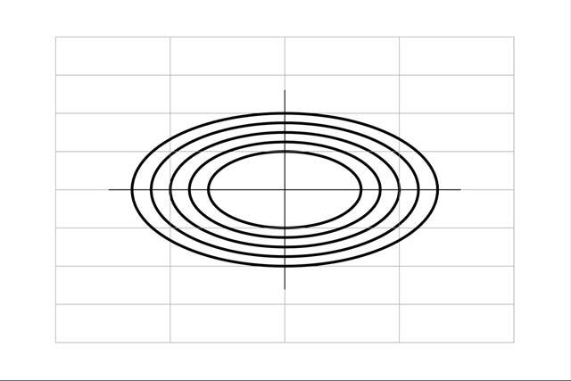

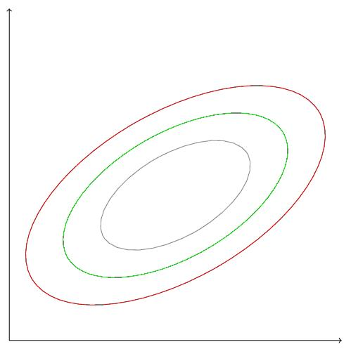
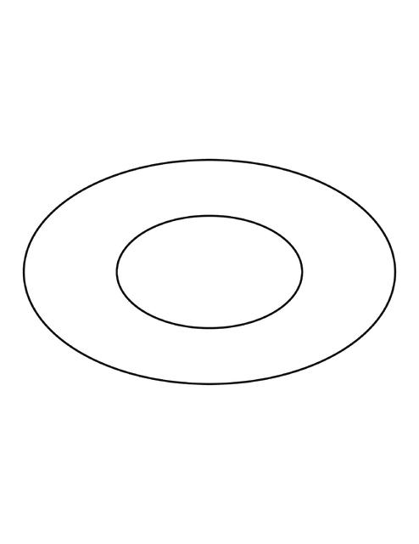
The exact mathematical properties depend on the boundary curves.

Classification Summary
# Source: AI Source: Provided by: [Data Path: Persons Table -> ID Column: 1, Name_En Column: Motasem Essam] -> From: [ChatGPT] on [7/25/2026]
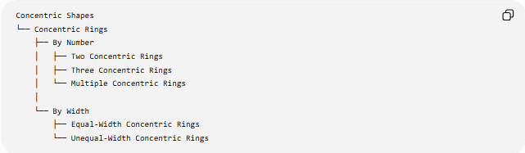
Concentric Shapes
└── Concentric Rings
├── By Number
│ ├── Two Concentric Rings
│ ├── Three Concentric Rings
│ └── Multiple Concentric Rings
│
└── By Width
├── Equal-Width Concentric Rings
└── Unequal-Width Concentric Rings
For circular rings:
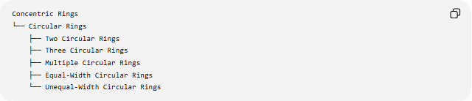
Concentric Rings
└── Circular Rings
├── Two Circular Rings
├── Three Circular Rings
├── Multiple Circular Rings
├── Equal-Width Circular Rings
└── Unequal-Width Circular Rings

Key Points
# Source: AI Source: Provided by: [Data Path: Persons Table -> ID Column: 1, Name_En Column: Motasem Essam] -> From: [ChatGPT] on [7/25/2026]
- Concentric rings share a common center.
- A circular ring is the region between two concentric circles.
- A circular ring is also called an annulus.
- Each circular ring has an inner radius $r$and an outer radius $R$.
- Ring thickness:
$$\boxed{t=R-r}$$
- Ring area:
$$\boxed{A=π\left(R^{2}-r^{2}\right)}$$
- Multiple concentric rings can have equal or unequal widths.
- Concentricity does not require equal ring widths.
- Concentric rings are regions, whereas concentric circles are boundaries.
- Concentric rings can be generalized to other centrally nested closed boundaries.

Conclusion
# Source: AI Source: Provided by: [Data Path: Persons Table -> ID Column: 1, Name_En Column: Motasem Essam] -> From: [ChatGPT] on [7/25/2026]
Concentric Rings are nested ring-shaped regions that share a common center. The most common example consists of multiple circular rings, or annuli, formed by successive concentric circles. Their geometry is naturally described using inner and outer radii, radial thickness, circumference, and area.

